Example 1:

Setup

(Optional) Flip a card from the Galaxies deck to determine the game setup. Otherwise allow the computer to randomize.

1. The Galaxy is randomized/shuffled and is placed face down

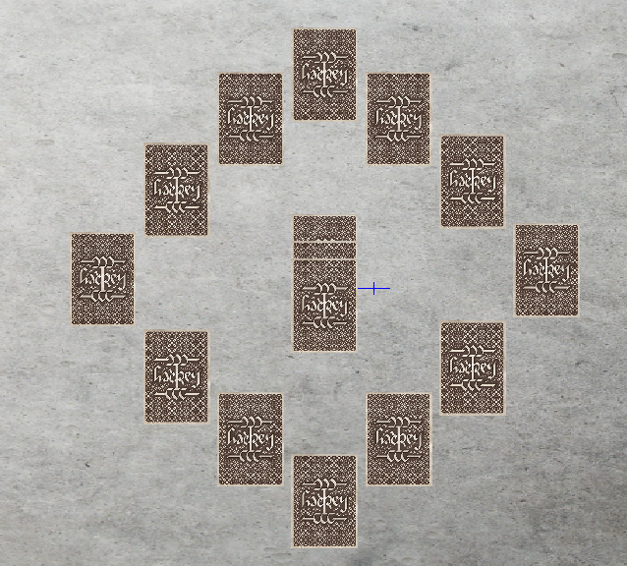

1. The Deck is placed in the center of the Galaxy
2. The Hour Hand and Minute Hand are randomized and placed at 1:45
3. Since you have traveled to the most foreign cities, you will take your turn first.
4. Since you are the starting player. you draw five cards from the top of the Deck into your Hand.
   * Your Hand: 2 Scalvage Drones, 1 Planet, 2 Star cards
5. Since play moves Clockwise, the players clockwise (left) of you take their turn drawning 5 cards from the top of the Deck.

Turn 1 (You)

1. You decide to Reveal a card in the Galaxy. You Reveal a Planet (Planet ZOD) that deals 4 Explosion to the card that is directly across from it within the Galaxy.

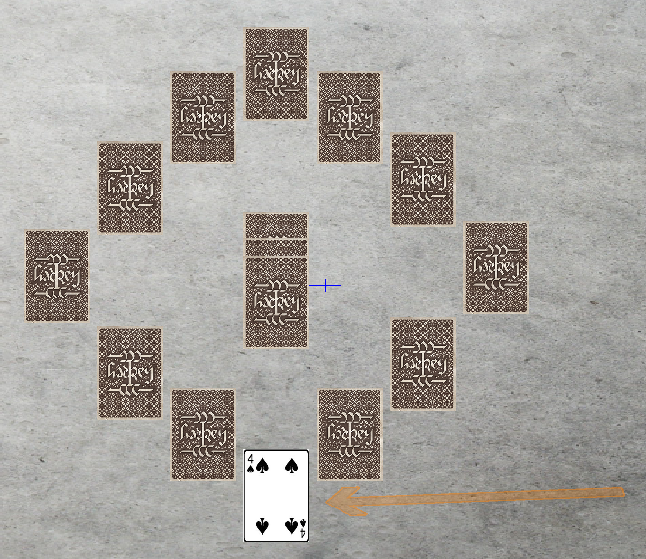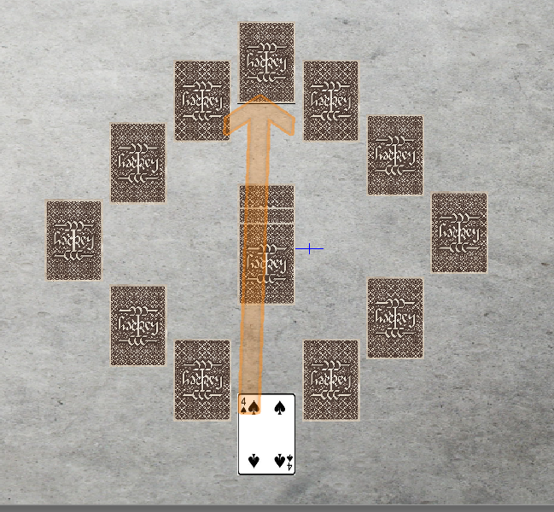

1. In order to deal the Explosion damage to the card across from your card, you Reveal that new card noting that it is a Planet (Planet Fizz) with 6 Hardness.
2. The damage dealt to Planet Fizz is marked with counters. Note, Planet Fizz isn't destroyed since it's Hardness is 6 and only 4 Explosion was dealt to it.

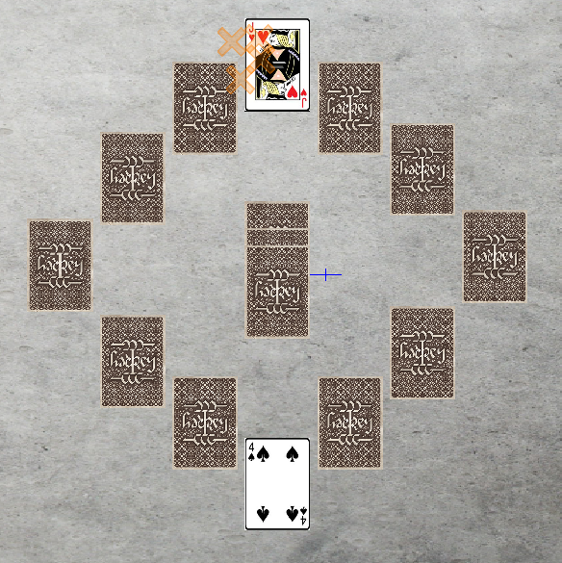

1. You decide not to Deploy a card from your Hand.
2. You Draw a card from the Top of the Deck into your Hand noting that it is an Escape Pod and your turn ends.
3. The Minute Hand moves 1 position Clockwise
   * If this card had already been Revealed, it's Hardness and Explosion would be doubled while the Minute Hand remains on it, otherwise that card stays conceled)

Turn 2 (Opponent A)

1. Opponent A decides to Deploy a Planet on top of the previously Revealed Planet ZOD in the Galaxy and resolve it's actions. This new Planet (Planet Haze) deals 3 Explosive damage to the card to it's right. Opponent A Reveals that card, but it's an Escape Pod. Because this card is not a Planet or a Star, Opponent A must take that card into their Hand.

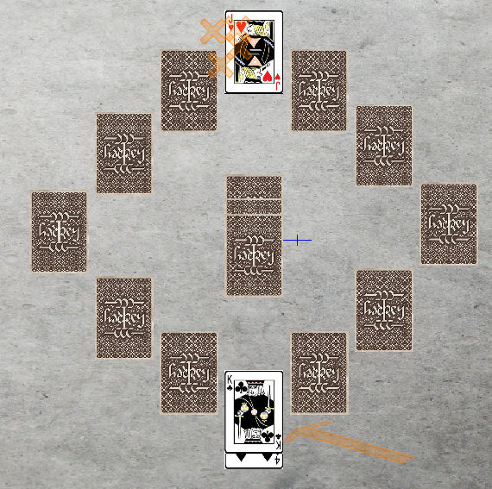

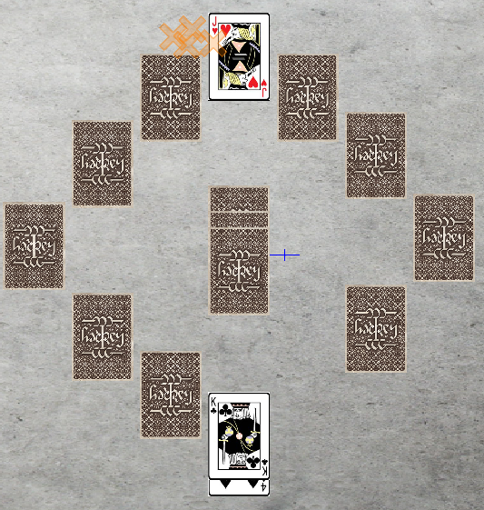

1. Opponent A decides not to Deploy a card from their Hand.
2. Since it is the end of Opponent A's turn, Opponent A Draws a card from the Top of the Deck noting that it is a Star and thus, must be Deployed immediately.
3. Opponent A Deploys the Star (Star 124B) on top of Planet Haze and resolves it's actions dealing 3 Explosion damage to to a new Star (Star 1ZZV), destroying the new Star.

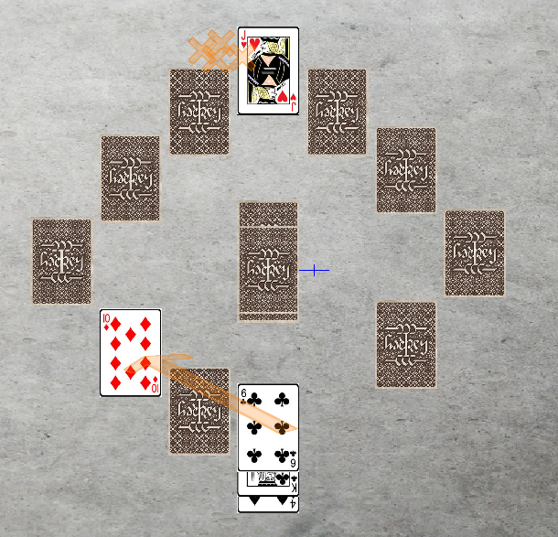

1. To wrap up, Opponent A must Deploy or Discard down to 5 cards, Opponent A Discards 1 card (Escape Pod) and Opponent A's turn ends.
2. The Minute Hand moves 1 position Clockwise

Turn 3 (You)

1. You decide to Reveal another card in the Galaxy. You Reveal a Scavage Drone and thus, add this card to your Hand.

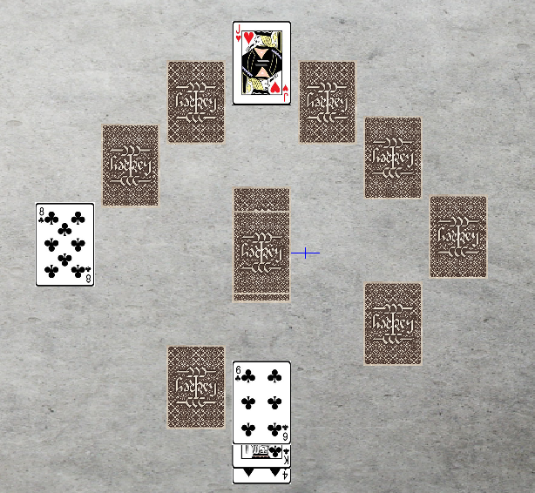

1. Since you have a Scalvage Drone in your Hand, you Deploy your Scalvage Drone on Planet Fizz (Since it isn't destroyed yet) and set Planet Fizz aside into your Fuel Pile and play contines.

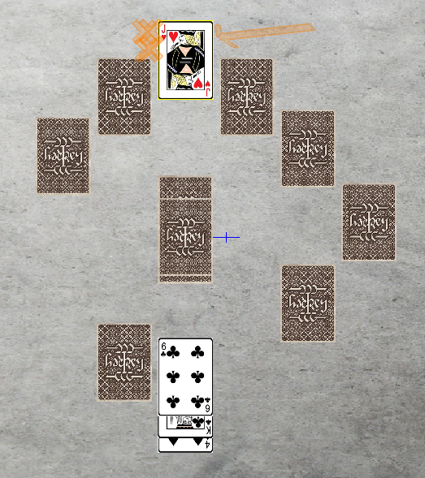

1. As you have Releaved 1 Card ifrom your Hand and Deployed 1 Card from the Galaxy, your turn must end. You Draw a card from the top of the Deck into your Hand noting that it is an Escape Pod. Your turn Ends.
2. The Minute Hand moves 1 position Clockwise